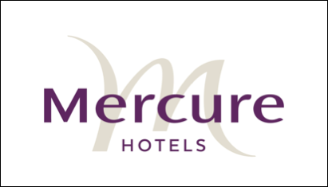

Beverages

Hahn light $5.50
Toohey’s New $6.00
Toohey’s Old $6.00
XXXX Gold $6.00
Toohey’s Extra Dry $6.00
Yenda Pale Ale on Tap $6.00
Yenda Hell – Lager on Tap $6.00
Pure Blonde $7.00
Corona $7.00
James Boags $7.00
Vodka Cruisers $9.50

Soft Drinks
Coke, Diet coke, Lift, Sprite, Juice $4.00
Lemon Lime Bitters $6.00
Ginger Beer $5.50
Bottled Water $3.50
Sparkling Mineral Water 500ml $6.50
Wild Sparkling Mineral Water- Pineapple, Lime, Passionfruit $6.50

Spirits
Standard $8.00
Deluxe $9.00
Liquors $10.50
Galway Pipe Port $10.50

