Congratulations on your engagement!!
Thank you for considering the Monte Pio Hotel for your future celebration. Your wedding day should be one of the happiest and most memorable days in your life. At the Monte Pio, we have played a part in providing the backdrop to many wonderful and unforgettable celebrations.
At the Monte Pio we believe that your wedding day should be a truly special occasion and to achieve this we provide the complete package. First-class service, inspired decorating, superb food, and a beautiful and historic setting, merge to create an outstanding event.
When choosing a venue for your wedding day you want to be confident that you’ll be in the hands of experts, giving you worry free service and support, allowing you to enjoy the journey. At the Monte Pio, Hunter Valley, we see our role as just that – doing our best so that you can relax and experience all your day should be.
Our wedding packages and associated information is provided for your perusal. However, at the Monte Pio we understand that all weddings are unique and therefore each of the packages can be modified to suit your particular needs
.
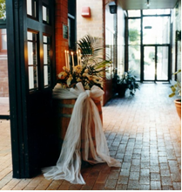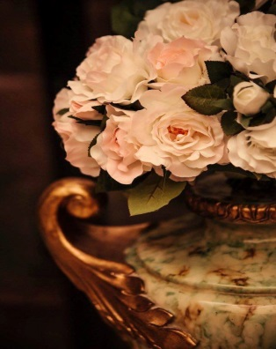

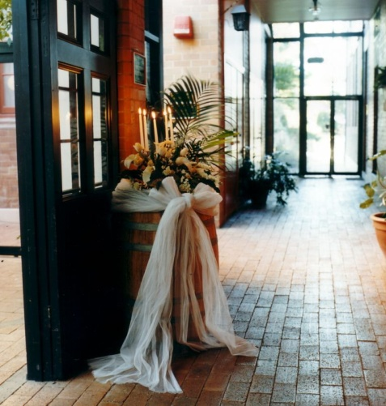
The Mercure Monte Pio represents modern elegance in an historic setting.
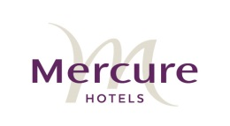
Weddings at the Mercure Monte Pio
The Monte Pio onsite Function Coordinator will work with you to help plan a wonderful wedding day. The Function Coordinator will help reserve your dates, manage your food and beverage package, organize the wedding day schedule, and assist with other aspects related to your wedding.

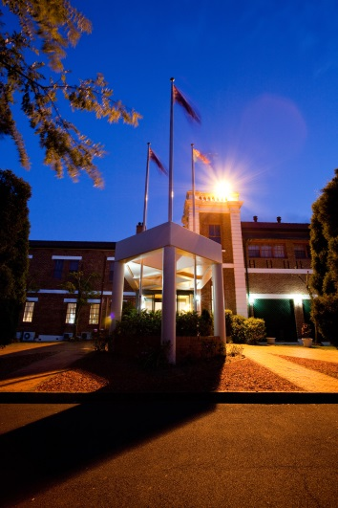
The Setting
The Historic Monte Pio offers a range of truly beautiful areas for wedding photography. Located on five picturesque acres in the Hunter Valley, the historic Monte Pio is a gorgeous heritage building that combines modern elegance and historical significance. Tastefully renovated, the former orphanage and ladies college offers a number of reception rooms, each distinctive and beautiful.

The Ceremony

In addition to beautiful wedding receptions, the Monte Pio can provide a beautiful setting for your marriage ceremony. With the use of a civil marriage celebrant a number of our guests have chosen to conduct their entire wedding journey at the Mercure Monte Pio. The stunning Courtyard atrium, located in the heart of the hotel, provides a breathtaking backdrop for your nuptials. With an outdoor garden like atmosphere and seating for 60, the Courtyard is a wonderful place to take your vows. This package includes: Red carpet with rose petals, garden arch, skirted signing table, 40 wicker chairs for guests.
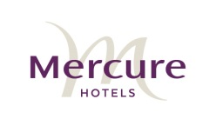
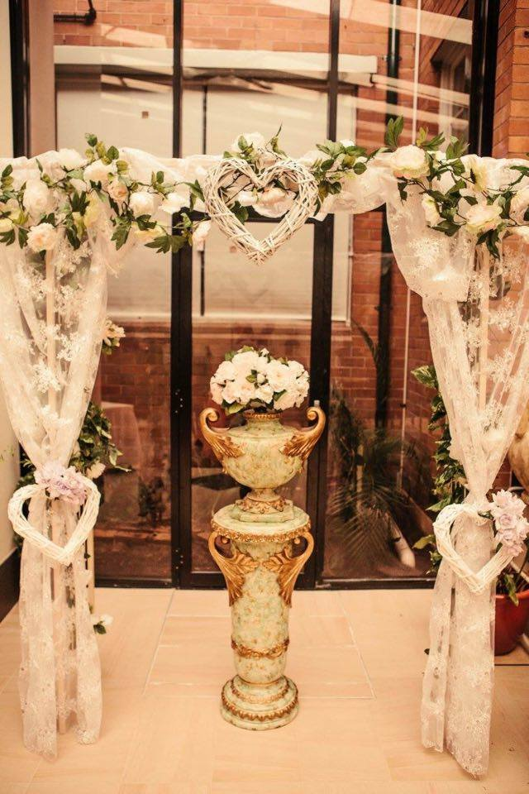

The Ballroom
“The Ballroom” is the perfect wedding reception venue, tastefully appointed with seating for up to 110 guests. In addition, the Ballroom has its own exclusive bar area and restrooms. “The Ballroom” exudes charm and that special something that only a property rich in history can offer. A $500.00 Room hire includes set up to your specific requirements and service staff to attend to you and your guests. The Ballroom hire on Sunday is $750.00.
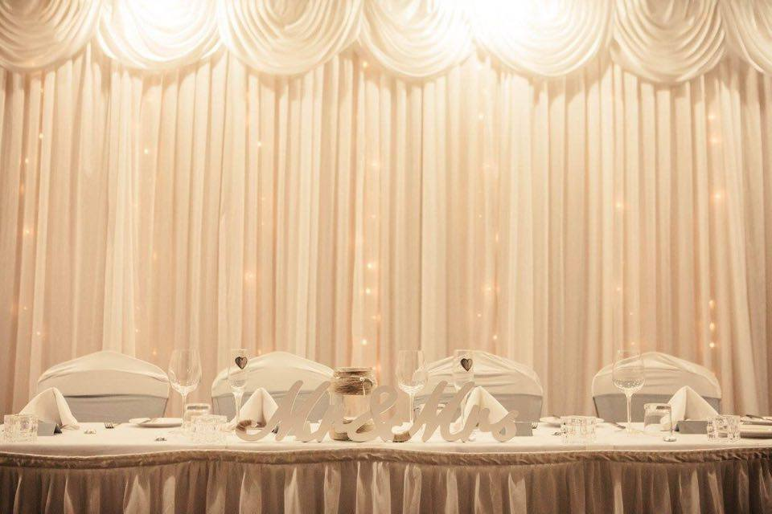

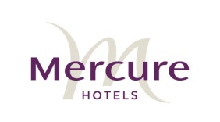
Standard Inclusions
- Wedding announcement displayed at Reception
- Crisp white linen
- Opulent white skirting for bridal, cake and gift tables
- Complimentary PA system suitable for speeches
- Exclusive Bar area with dedicated bar staff
- Private restrooms
- A dedicated function coordinator to help plan your special day
- The Norfolk
- Named the ‘The Norfolk’ after the historic Norfolk pines that still stand on the property, the “Norfolk room” caters for receptions for up to 60 guests. A $500.00 Room hire includes set up to your specific requirements and service staff to attend to you and your guests. The room hire on a Sunday is $750.00. Ideally located with its own dedicated entrance and veranda away from the other rooms, The Norfolk ensures that your wedding reception is private and exclusive. The Norfolk room offers a more intimate experience with all the inclusions, charm and atmosphere only the Monte Pio, Hunter Valley can offer.
- .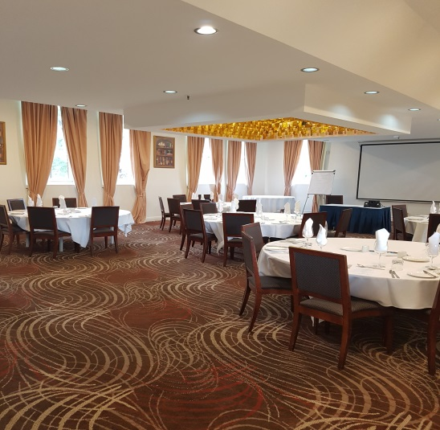
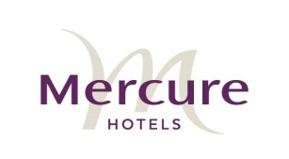
Standard Inclusions

- Wedding announcement displayed at Reception
- Crisp white linen
- Opulent white skirting for bridal, cake and gift tables
The Pines Restaurant

- The splendid French Renaissance décor of the Pines Restaurant makes this setting genuinely magical. Opulent window dressings, classic dark wood furniture, magnificent grand bookcases, and large windows revealing a glorious plains landscape merge to create a beautiful wedding setting. The Pines restaurant seats 90 and has a private bar area.
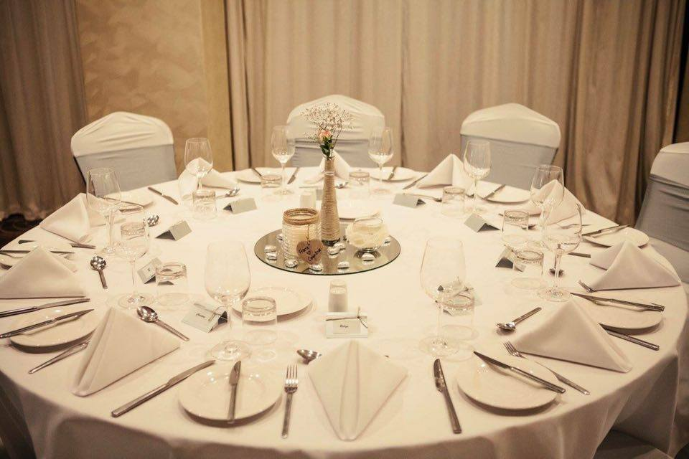

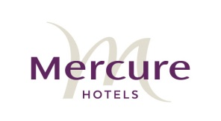

Standard Inclusions

- Wedding announcement displayed at Reception
- Crisp white linen
- Opulent white skirting for bridal, cake and gift tables
- Exclusive Bar area with dedicated bar staff
Please note: our Restaurant is a $500 fee and $750 on Sundays.
Room Specifications

Room | Dimensions  W x L | Ceiling Height | Banquet Seating | Air-  conditioning
Ballroom | 11m x 20m | 3.2m | 110 | Yes
Norfolk | 10m x 15m | 2.7m | 60 | Yes
Toohey | 10m x 15m | 4m | 50 | Yes
Pines  Restaurant |  |  | 90 | Yes
Courtyard  Atrium |  |  | 50 | No

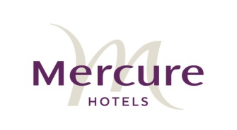

Menus

The following menus and packages set the Monte Pio apart from the other venues in the Hunter Valley. Ask our Function Co-coordinator about any variations you feel might make your day even more memorable. We would be delighted to work with you to custom design your Wedding Reception.

Accommodation

All our wedding packages include a special gift for you:
- One night complimentary stay in our royal spa suite
- Full buffet breakfast the following morning.
- We can offer the corporate rate for your guests who wish to stay with us; they will just need to mention they are with your wedding when making the booking.

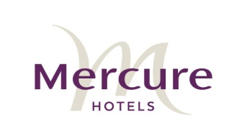

The Carvery

(Please select two of the following roasts to be served alternately)

Warm Bread Rolls & Butter

Roasted Sirloin of Beef

Stuffed & Rolled Loin of lamb

Basted Turkey Buffe

Stuffed & Rolled Loin of Pork

A Selection of Roast Vegetables, Steamed greens, Seasonal Garden Salads, Sauces & Condiments

Dessert

Your choice of two from the Patisserie Menu

Fine Teas & Brewed Coffee

Your wedding cake can be cut and plated as dessert

Please note: This package can be plated and served alternatively.

$58.00 per person

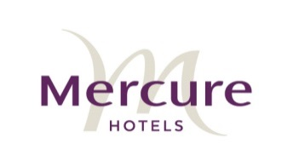

The Semillon

Canapes

Choose 4
Served for 1 hour

Bruschetta
Chicken Satay skewers
Quiches
Spring rolls
Salt and pepper squid
Pizza bites

Warm bread rolls with butter

Main

Sirloin steak with baked potato, grilled tomato and pepper sauce

Chicken breast with garlic chats and mustard Jus

Dessert

Cut and plate wedding cake
Tea and coffee

$60.00per person

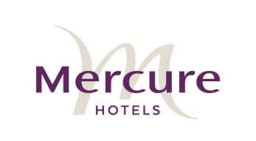
The Verdelho
Select any two choices from each course – served alternately

Warm Bread Rolls & Butter

Entrees

Garlic or Chilli Tomato Prawns on Steamed Rice (prices may vary)

Thai Beef Salad

Smoked Salmon Caesar Salad

Chicken & Cashew Vol au Vent with Rice

Wok Fried Goujon of Beef with Vermicelli Noodles, Asian Greens & Mild Chilli

Mains

Cajun Chicken Breast w/- Prawns in a Cajun Cream

Atlantic salmon on wilted greens and potatoes with a herb cream sauce

Barramundi with mushroom and sun-dried tomato risotto with white wine cream sauce

Prime Beef Rib Steak on Shallot Mash w/- Wilted greens & Red wine Jus

Chicken Breast filled w/- Mexican Farce baked in Filo & topped w/- Tomato Salsa

All served w/- steamed vegetables

Desserts

Your Choice of two from the Patisserie Menu
Your wedding cake can be cut and plated as dessert

$95 per person
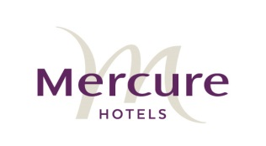
The Sauvignon Blanc

Select any two choices from each course – served alternately

Warm Bread Rolls & Butter
Entrees
Fresh King Prawns resting on a Wonton Stack w/- Chargrilled Asparagus & Saffron Aioli

Spicy Chicken Tenders infused w/- Harissa on Seasoned Rice w/- Chilli Plum Dipping Sauce

Sri Lankan Stir-fried Squid w/- Garlic & Ginger Paste

Roast Beetroot & Basil Salad w/- Creamy Horse Radish Dressing

Caramelised Onion & Bacon Tart w/- fried Leek & Balsamic Port Reduction
Mains

Sautéed Fillet of Blue Eyed Cod w/- Herbed Couscous, Baby Bok Choy & Lemon Sauce

Slow Roasted Prime Beef Rib w/- Heirloom Tomatoes, Baked Potato & Jus

Pork Loin Baked Apple & Glazed Carrots

Veal Oscar topped w/- Chargrilled King Prawns, Asparagus & Hollandaise

Mediterranean Chicken Breast on Garlic Potato & Wilted baby Spinach w/- Black Olive & Fetta Crumble
Dessert
Your choice of two from the Patisserie Menu

Your wedding cake can be cut and plated as dessert
$120 per person

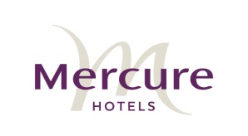
The Pinot Noir
Selection of Canapés served on arrival

Select any two choices from each course – served alternately
Warm Bread Rolls & Butter

Entrees
Salmon Timbale w/- Blue Swimmer Crab, Avocado, Chilli, Coriander & Ponza Mayonnaise

Peppered Lamb Fillets on Mixed Lettuce w/- Balsamic Reduction

Tempura Tiger Prawns on Tropical Salad w/- Citrus Dressing

Vegetable Stack w/- Marinated Fetta, Goats Cheese & Pepperonata Coulis

Mains

Singapore Chilli Mud Crab on Steamed Basmati Rice

Grange Beef Fillet w/- Poached Scampi & Roast Kipflers on Wilted Greens & Saffron Aioli

Baked Whole Salt & Pepper Snapper w/- Cajun Spices on Wok Fried Asian Greens w/- Lime Dressing

Pork Fillet on Caramelised Apple Coujons w/- Buttered Beans & Port & Sultana Glaze

Whole Baby Barramundi w/- Boutique Salad & Lemon Beurre Blanc

Baby Lamb Rack on Mash w/- Snow Peas & red Wine Jus

Desserts

Your choice of two from the Patisserie Menu
Your wedding cake can be cut and plated as dessert

$150 per person

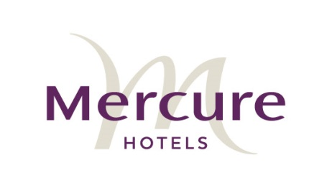

Canapes

4 items - $18.00
6 items - $24.00

Cold selection

Bruschetta on crostini
Olive bread w/ - goat’s cheese & onion compote
Beef fillet on crostini w/- beetroot & horse radish cream
Smoked salmon blinis w/- wasabi cream

Hot selection

Assorted pizza bites
Persian fetta & rocket filo’s
Moroccan meatballs w/- mint yoghurt dressing
Coconut crumbed prawns w/- Thai flavours & aioli dipping sauce
Satay chicken skewers

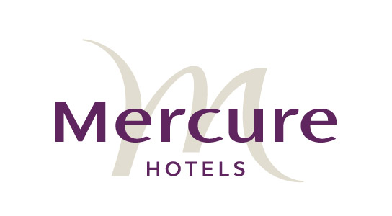

Terms and conditions

All wedding reception reservations are made in accordance with our terms and conditions.

The management and staff at the Mercure Monte Pio would like to make sure your wedding reception is special in every way. Please read this information carefully and complete the wedding confirmation form to confirm your wedding reception booking.

Organising your wedding reception
To allow us to finalise all details and meet your requirements we ask that you make an appointment with our Function Coordinator. All details of your wedding reception are required to be finalised not less the fourteen (14) days prior to the event. All wedding receptions are to conclude by 11.30pm, music must be off by 11pm. To ensure hotel guests are not inconvenienced. Events that are catered for or continue after midnight incur a $250.00/ hour charge.

Deposits
Once you have decided that the Mercure Monte Pio is the ideal wedding reception venue a security deposit of $500.00 or 20% (whichever is greater) is required within fourteen (14) days of making a tentative booking with us. This deposit will secure your booking.

Final Numbers
Final numbers are required five (5) business days prior to your wedding date. This will be the minimum number for which you will be charged. Full payment is required three (3) working days prior to your wedding reception and can be made either by bank cheque, cash or credit card. Personal cheques will only be accepted by prior arrangement with management.

Liability
At the Mercure Monte Pio we are extremely careful when it comes to our guests and their belongings. Unfortunately, we cannot accept responsibility for guests’ personal effects, equipment or valuables. Monte Pio also cannot be held responsible for lack of services available by any contractors or sub- contractors appointed by the Mercure Maitland Monte Pio on behalf of the client.

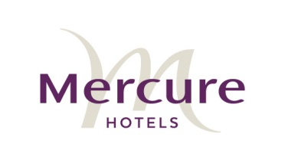

Responsible Service of Alcohol
The Mercure Maitland Monte Pio fully supports the responsible service of alcohol and we reserve the right to refuse service of alcohol to any person who we believe to be intoxicated. Anyone we believe to be underage.

Damage to the Monte Pio
Any damage sustained to the Mercure Monte Pio by the event organiser or their guests is the responsibility of the event organiser. The event organiser is also responsible to ensure and reasonable level of conduct of their guests during the wedding reception. A fee of $250.00 is charged is there is blood or vomit which needs to be cleaned by our staff.

Cancellation
In the event confirmed wedding reception being cancelled, notice in writing must be forwarded to our Coordinator and the following will apply:
- If cancelled more than sixty (60) days prior to the function the deposit will be refunded, less an administration fee of $150.00, provided the room is subsequently re-booked.
- If cancelled less than sixty (60) days prior to the function no deposit or payments will be refundable.
Please Note: a date change that is less than sixty (60) days’ notice is given will result in forfeit of the security deposit unless room can be re-booked.

Extra charges
While Mercure Monte Pio will endeavour to maintain all our printed prices and menu suggestions, they are subject to change without notice at management’s discretion. Events held on a public holiday incur a 10% surcharge.

Thank you for choosing to book your wedding with the Mercure Monte Pio. You can be assured that we will do our best to make your day one to remember.

All food and beverage consumed in meeting rooms, restaurant, bars and function areas must only be that which the hotel has provided. No outside catering or beverages can be brought into the hotel.

